A Project- I Report on
IMAGE CAPTION GENERATOR

Submitted in partial fulfillment of the requirements for the degree of
Bachelor of Engineering in Software Engineering at Pokhara University

By
ANKIT ADHIKARI
BISWAS BANSTOLA



Department of Research and Development
GANDAKI COLLEGE OF ENGINEERING AND SCIENCE
Lamachaur, Kaski, Nepal
(2025,Nov,9)

A Project- I Report on
IMAGE CAPTION GENERATOR

Submitted in partial fulfillment of the requirements for the degree of
Bachelor of Engineering in Software Engineering at Pokhara University

By
ANKIT ADHIKARI
BISWAS BANSTOLA

SUPERVISOR
Er. Pratikshya Shrestha

Department of Research and Development
GANDAKI COLLEGE OF ENGINEERING AND SCIENCE
Lamachaur, Kaski, Nepal
(2025,Nov,9)

APPROVAL CERTIFICATE
This project entitled "Image Caption Generator" prepared and submitted by "ANKIT ADHIKARI, BISWAS BANSTOLA" under the supervision of "Pratikshya Shrestha" in partial fulfillment of the requirements for the Degree of Bachelor of Engineering in Software Engineering has been examined and is recommended for approval and acceptance.

Date of Evaluation: MAY,2025

…………………………………
Er. Pratikshya Shrestha
Supervisor’s name

…………………………………
Er. Santosh Panth
Project Head
Research Management Committee
Gandaki College of Engineering and Science
BONAFIDE CERTIFICATE
This is to certify that this project titled IMAGE CAPTION GENERATOR in partial fulfillment of the requirements for the degree of BACHELOR OF ENGINEERING IN SOFTWARE ENGINEERING is a bonafide work of Ankit Adhikari, Biswas Banstola under the supervision of Er.Pratikshya Shrestha. It is further certified that this work doesn't form part of any other project work on the basis of which a degree or award was conferred on any earlier occasion on this by any other candidate.

Date of Evaluation:

ABSTRACT
The project presented a web-based image captioning system capable of automatically generating captions for uploaded image. The system was trained on the Flickr30k dataset to learn relationships between visual features and language. Visual features were extracted using a EfficientNet model, and a Transformer-based network was employed to generate coherent textual descriptions. The developed web interface enabled users to upload images and instantly obtain captions. The system demonstrated the effective integration of deep learning techniques to achieve automated imageCaption generation.
Keywords: Transformer,Caption , Dataset,.

TABLE OF CONTENTS
APPROVAL CERTIFICATE iii
TABLE OF CONTENTS vi
LIST OF FIGURES vii
LIST OF TABLES viii
Introduction 1
1.1Background 1
1.2 Problem Statements 1
1.1 Objectives 1
1.4 Implications 2
Literature Reviews 3
2.1 Similar literatures 3
2.1.1 A Deep Neural Framework for Image Caption Generation Using GRU-Based Attention Mechanism 3
2.1.2 An Intelligent Image Caption Generator Model using Deep Learning 3
2.1.3 Show and Tell: A Neural Image Caption Generator 4
2.1.4 Self-critical Sequence Training for Image Captioning 4
2.1.5 Camera2Caption: A real-time image caption generator 5
Tools And Methodology 7
3.1 Required Tools 7
3.2 Methodology 8
3.2.1 System Development Method 8
3.2.2 Datasets 10
3.2.3 Designs 11
3.3 Algorithms 15
Result and Discussion 17
Timeline chart 18
Bibliography 19
Appendices 20

LIST OF FIGURES

Figure 3.2.2.1 Phases of Iterative and Incremental Model 8
Figure 3.2.2.2 Structure of Iterative and Incremental Model 9
Figure 3.2.3.1 Use Case Diagram 12
Figure 3.2.3.2 Entity Relationship Diagram 15
Figure 3.2.3.3 System Sequence Diagram 16
Figure 3.3.1 EfficientNet-B0 Architecture 17
Figure 5.1 Gantt Chart 20

LIST OF TABLES
Table 2.1 Literature Review 6
Table 3.1.1 Required Tools 7
Table 3.1.2 Required Programming Languages 7

Chapter 1

Introduction

1.1Background
The rapid growth of digital media has made it increasingly difficult to manage and interpret images without descriptive text. Manually writing captions for large numbers of images was a tedious and time-consuming process. This project addressed this challenge by developing a web-based application capable of automatically generating descriptive captions for uploaded images. The solution utilized recent advancements in artificial intelligence, combining computer vision techniques to enable machines to interpret and describe visual content.

1.2 Problem Statements
The exponential growth of online visual content had created significant challenges in organizing and identifying images without accompanying textual descriptions. Manual annotation of images was time-consuming and inefficient, particularly for large datasets. To address this issue, the project focused on developing an automated caption generation system capable of producing meaningful descriptions for uploaded images. This system aimed at simplifying the understanding and utilization of digital images by leveraging artificial intelligence techniques..

Objectives
To provide users with a simple way to upload images and receive relevant caption.

1.4 Implications
This automated image captioning website offers a practical and efficient solution for describing online visual content, saving time and resources compared to manual methods. It also improves accessibility for visually impaired users by providing automatic text descriptions. Furthermore, it can assist content creators in generating engaging captions for wider reach. The project demonstrates the application of advanced AI techniques for image understanding and natural language generation.

Chapter 2

Literature Reviews

2.1 Similar literatures
There are already some projects and articles out there that try to automatically write captions for pictures. Our goal is to build a website that's even easier to use and gives really good captions using the latest smart computer technology. We want to make it simpler for people to get descriptions of their images. Here are a few examples of similar things:

2.1.1 A Deep Neural Framework for Image Caption Generation Using GRU-Based Attention Mechanism
This paper introduces a deep learning framework for automated image caption generation. The authors utilized the MS COCO dataset for training and evaluation. Their proposed architecture consists of a pre-trained Convolutional Neural Network (CNN) for extracting visual features, which are then fed into a Gated Recurrent Unit (GRU)-based Recurrent Neural Network (RNN) acting as the decoder. A key component of their approach is a GRU-based attention mechanism, which enables the decoder to focus on the most relevant spatial regions of the input image during the generation of each word in the caption sequence. The authors suggest future work could focus on exploring more sophisticated attention mechanisms and incorporating semantic information to further improve the quality and relevance of the generated captions.
. [1]

2.1.2 An Intelligent Image Caption Generator Model using Deep Learning
An Intelligent Image Caption Generator Model using Deep Learning presents a deep learning model for automatically generating captions for images. The authors developed a framework utilizing a Convolutional Neural Network (CNN) for image feature extraction and a Long Short-Term Memory (LSTM) network, a type of Recurrent Neural Network (RNN), for generating textual captions. The study evaluated the performance of their model using the Flickr8k dataset. While the paper details the architecture involving CNNs and LSTMs for encoding visual information and decoding it into natural language. The paper concludes by highlighting the potential of their approach for various applications requiring image understanding and description. [2]

2.1.3 Show and Tell: A Neural Image Caption Generator
The creators used a special kind of computer brain called a CNN (specifically Inception v3) to understand what's in the image. This understanding was then fed into another type of computer brain called an RNN, using LSTMs, which generated the caption word by word. The whole system was trained to try and match the computer-written caption as closely as possible to real human captions. They tested it on two big collections of images and captions, Flickr30k and MS COCO, and it did a pretty good job of describing various pictures. The researchers also pointed out that the system could get better at handling words it hadn't seen much before, writing more varied and interesting captions, and focusing on the most important parts of the picture when describing it. [3]

2.1.4 Self-critical Sequence Training for Image Captioning
“Self-Critical Sequence Training for Image Captioning” addressed the challenge of generating natural-sounding image descriptions by introducing a novel reinforcement learning approach. Instead of training word by word, this method trains the computer to generate entire captions and rewards it based on how well those captions score against human evaluations, using its own initial output as a baseline for improvement. Utilizing a CNN for image understanding and an LSTM for caption generation, this technique was tested on the MS COCO dataset and significantly improved the quality of generated captions.
This research emphasizes the importance of optimizing overall caption quality and has influenced subsequent work in the field, suggesting future directions in refining reward mechanisms and exploration strategies, often employing optimizers like Adam. This approach highlights the need to consider holistic caption quality in our project's development. [4]

2.1.5 Camera2Caption: A real-time image caption generator
The "Camera2Caption" paper focused on creating a real-time image captioning system that could operate on low-end hardware like smartphones. The researchers simplified the typical deep learning approach, using a basic encoder (CNN) and decoder (GRUs/LSTMs) architecture optimized for speed. Trained on the MSCOCO dataset, their model achieved real-time performance, demonstrated through an Android application, but with a noted trade-off in caption accuracy compared to more computationally intensive models.
The study highlights the challenges of balancing speed and quality for practical, real-time applications of image captioning on resource-constrained devices, suggesting future work could explore methods to enhance accuracy without significantly impacting processing time. [5]
Table 2.1 Literature Review matrix
S.N. | Project Name | Dataset Used | Size of Dataset | Encoder used |  | Decoder Used
1 | A Deep Neural Framework for Image Caption Generation Using GRU-Based Attention Mechanism. | MS COCO | 25–30 GB | Convolutional Neural Network | GRU-based RNN with Bahdanau attention mechanism
2 | An Intelligent Image Caption Generator Model using Deep Learning | Flickr8k | 1 GB | CNN | LSTM
3 | Show and Tell: A Neural Image Caption Generator | Flickr30k and MS COCO | 4.39 GB | Inception v3 | LSTM
4 | 4 Self-critical Sequence Training for Image Captioning | MS COCO | 25–30 GB | CNN | LSTM
5 | Camera2Caption: A real-time image caption generator | MS COCO | 25–30 GB | CNN | GRUs and LSTM
Chapter 3

Tools And Methodology

3.1 Required Tools
The following tools will be used for development of our project:
Table 3.1.1 Required Tools
Tools Name | Purpose
Vs code | To edit codes.
Microsoft Office Package | For document creation
Dia | To make ER-diagrams, use case diagrams, Sequence diagrams.
Figma | To Design Wireframes.
Kaggle | For Dataset and Free GPU Access.

Table 3.1.2 Required Programming Languages
Programming Language | Description
HTML | Structuring the webpage
CSS | Web page Styling
JavaScript | Frontend and Client-side programming
Python | Backend and Server-side Programming
SQLite | Database Handling

3.2 Methodology

3.2.1 System Development Method
Iterative and Incremental Model is used for developing the Image Caption Generator. This approach breaks the project into manageable parts and allows continuous improvement through multiple cycles.
1. Initial Planning & Requirements: The system enables user authentication, image upload, and automatic caption generation. Each uploaded image receives one caption.
2. Analysis & Design: Use case and ER diagrams are designed. Core entities include User, Image, and Caption, ensuring proper relationship mapping.
3. Incremental Implementation:
- First iteration focuses on registration, login, and logout functionalities.
- Second iteration adds image upload and caption generation.
- Later iterations include caption history viewing and deletion.
4. Testing & Evaluation: Each increment is tested individually for functionality, caption accuracy, and database performance. Feedback is used to improve the next cycle.
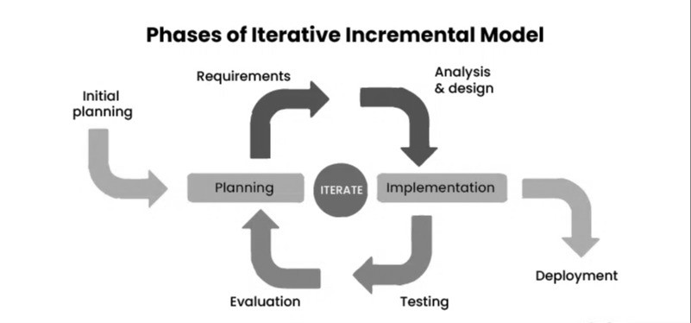
Figure 3.2.1.1 Phases of Iterative and Incremental Model [6]

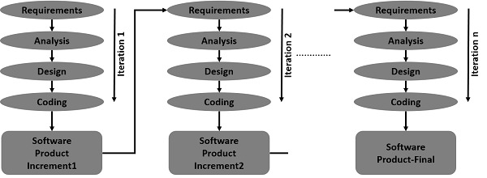
Figure 3.2.1.2 Structure of Iterative and Incremental Model [6]

3.2.2 Datasets
The datasets discussed here are commonly used for image captioning tasks and are sourced from platforms such as Kaggle. For this project, we are using the Flickr8k dataset.
Dataset Used: Flickr30K Image Dataset
- Description: The Flickr30k dataset contains 30,000 real-world images collected from the Flickr website, depicting everyday scenes and human activities.
- Captions: Each image has 5 human-written captions, offering diverse and descriptive text for training.
- Purpose: It is designed for image-to-text generation, making it ideal for training image captioning models.
- Use Case: Best suited for small to medium-scale research projects, offering a good balance between dataset size, diversity, and computational requirements.

3.2.3 Designs
Use-case Diagram :
. 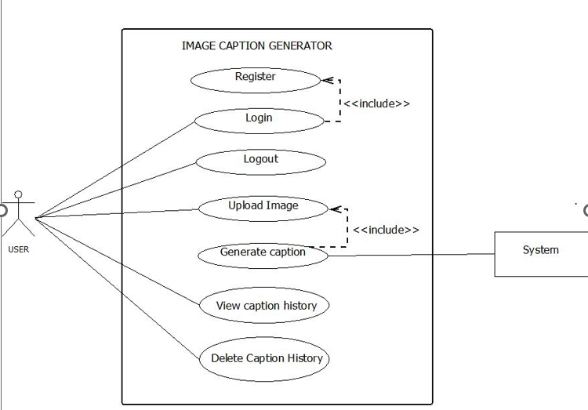
Figure 3.2.3.1 Use Case Diagram
UC1: Register
Primary Actor: User
Stakeholders:
- User: wants to register
- Admin: wants to update the database
Precondition: User should fill out the registration form
Post condition: The user can log in if he or she has already registered.
Basic Flow:
- User fills out the form
- User clicks on the register button
- Admin updates the user information in the database

UC2: Login
Primary Actor: User
Stakeholders:
- User: wants to access the system
- Admin: manages user authentication
Pre-condition: User must be registered in the system.
Post-condition: User is authenticated and gains access to system features.
Basic Flow:
- User enters login credentials (username and password).
- User clicks the "Login" button.
- The system verifies credentials.
- If valid, the user is redirected to the dashboard.

UC3: Upload Image
Primary Actor: User
Stakeholders:
- User: wants to upload an image for caption generation
- System: processes and stores the uploaded image
Pre-condition: User must be logged in.
Post-condition: Image is stored in the system, ready for caption generation.

Basic Flow:
- User selects "Upload Image."
- User selects an image file from their device.
- User submits the selected image.
- System validates and stores the image.
- System confirms successful upload.

UC4: Generate Caption
Primary Actor: User
Stakeholders:
- User: wants an AI-generated caption
- System: processes the image and generates a caption
Pre-condition: User must have uploaded an image.
Post-condition: System generates and displays a caption for the image.
Basic Flow:
- User selects "Generate Caption."
- System retrieves the uploaded image.
- System processes the image using AI algorithms.
- System generates a caption.
- System displays the caption to the user.

UC5: View Caption History
Primary Actor: User
Stakeholders:
- User: wants to view previous caption generations
- System: stores past generated captions
Pre-condition: User must have previously generated captions.
Post-condition: User views a list of past generated captions.
Basic Flow:
- User selects "View Caption History."
- System retrieves the user's past captions.
- System displays caption history to the user.

UC6: Delete Caption History
Primary Actor: User
Stakeholders:
- User: wants to remove unnecessary caption data
- System: manages caption storage
Pre-condition: User must have past captions stored in the system.
Post-condition: Selected captions are permanently removed from the system.
Basic Flow:
- User selects "Delete Caption History."
- System prompts user to select captions for deletion.
- User confirms the deletion request.
- System removes the selected captions.
- System confirms deletion.
Entity Relationship Diagram :
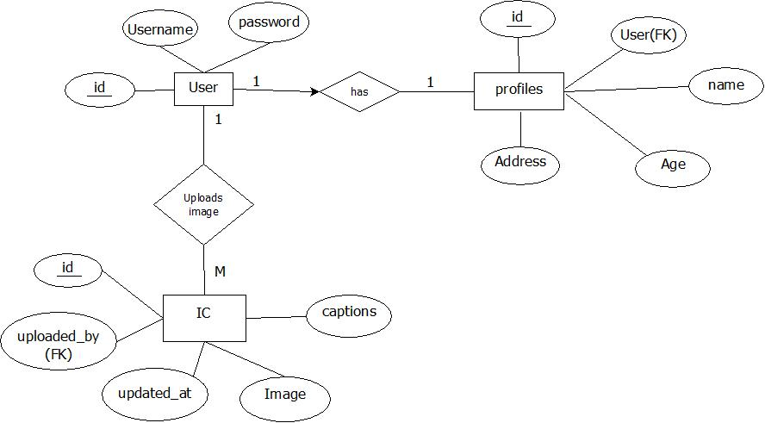
Figure 3.2.3.2: Entity Relationship Diagram

3.3 Algorithms
This project utilizes deep learning techniques for automated image captioning. The approach consists of EfficientNet as the encoder for feature extraction and a Transformer-based decoder for caption generation.
1. EfficientNet for Feature Extraction
EfficientNet is a convolutional neural network architecture designed to extract high-quality visual features from images with improved efficiency. It scales depth, width, and resolution in a balanced manner, allowing the model to achieve better accuracy with fewer parameters and lower computational cost. EfficientNet processes images through multiple optimized layers to capture essential details such as objects, textures, and spatial relationships. The final output is a compact feature vector, which serves as the input for the caption generation model.
Why EfficientNet:
- Balanced Scaling: EfficientNet scales network depth, width, and resolution uniformly, achieving high accuracy with optimized performance.
- High Efficiency: Delivers better feature extraction with significantly fewer parameters and lower computational cost compared to traditional CNNs.
- Improved Accuracy: Captures fine-grained visual details and spatial features effectively, producing high-quality feature vectors for caption generation.

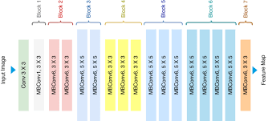
Figure 3.3.1 EfficientNet-B0 Architecture

2. Transformer-Based Decoder for Caption Generation
Once the visual features are extracted by ResNet-50, the Transformer decoder takes over to generate captions. The Transformer is particularly effective at handling sequential data, like text.
Why of the Transformer Decoder:
- Self-Attention: The Transformer uses the self-attention mechanism to focus on different parts of the image features and figure out which parts are most important for generating a coherent caption.
- Autoregressive Decoding: It generates words one-by-one, using previously generated words to predict the next word. This is typical of autoregressive models.
- Positional Encoding: Since the Transformer doesn't have a built-in sense of word order, positional encodings are added to indicate the position of each word in the sequence.

Chapter 4

Result and Discussion
The system was trained and tested using a dataset of around 30,000 images, which provided enough variety for generating captions. The results showed that the system could automatically create captions after the user uploaded an image. This was done using a pre-trained model for extracting image features and a decoder model for forming the sentences. The web application also offered a simple and easy-to-use interface, allowing both technical and non-technical users to interact with the system without difficulty. The project showed how deep-learning models can be used to convert visual information into text and apply these methods in a real application. A caption-history feature was also added, which stored uploaded images along with their generated captions, allowing users to view their past records. Since the platform was web-based, it could be accessed on different devices and operating systems, making it usable for a wide range of users such as students, researchers, educators, and developers.
.
Chapter 5

Timeline chart
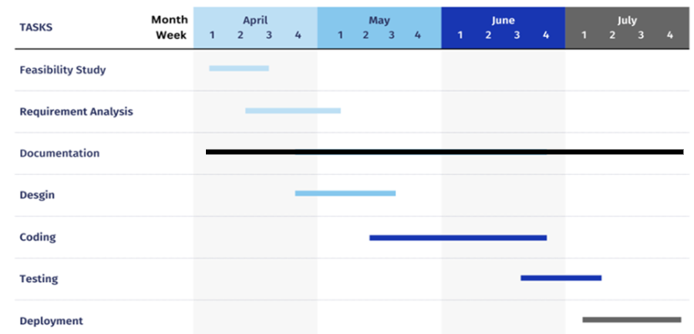
Figure 5.1 Gantt Chart

Chapter 6

Bibliography

[1] | S. Alharbi and A. Al-Salman, "A Deep Neural Framework for Image Caption Generation Using GRU-Based Attention Mechanism," arXiv, 2022.
[2] | K. Oluborode and . A. A. Kadams, "An Intelligent Image Caption Generator Model using Deep Learning," International Journal of Data Mining Techniques and Applications, 2024.
[3] | . O. Vinyals, A. Toshev, S. Bengio and D. Erhan, "Show and tell: A neural image caption generator," Proceedings of the IEEE Conference on Computer Vision and Pattern Recognition, pp. 3156-3164, 2015.
[4] | S. J. Rennie, E. Marcheret, Y. Mroueh, J. Ross and V. Goel, "Self-critical Sequence Training for Image Captioning," Proceedings of the IEEE Conference on Computer Vision and Pattern Recognition (CVPR), pp. 7008-7024, 2017.
[5] | P. Mathur, A. Gill, A. Yadav, A. Mishra and N. Bansode, "Camera2Caption: A real-time image caption generator," in International Conference on Computational Intelligence in Data Science (ICCIDS), Chennai, India, 2017.
[6] | G. f. Geeks, "Geeks for Geeks," [Online]. Available: https://www.geeksforgeeks.org/iterative-incremental-model-in-designing-system/.

Chapter 7

Appendices
Wireframes

Appendix 7.1: Landing page

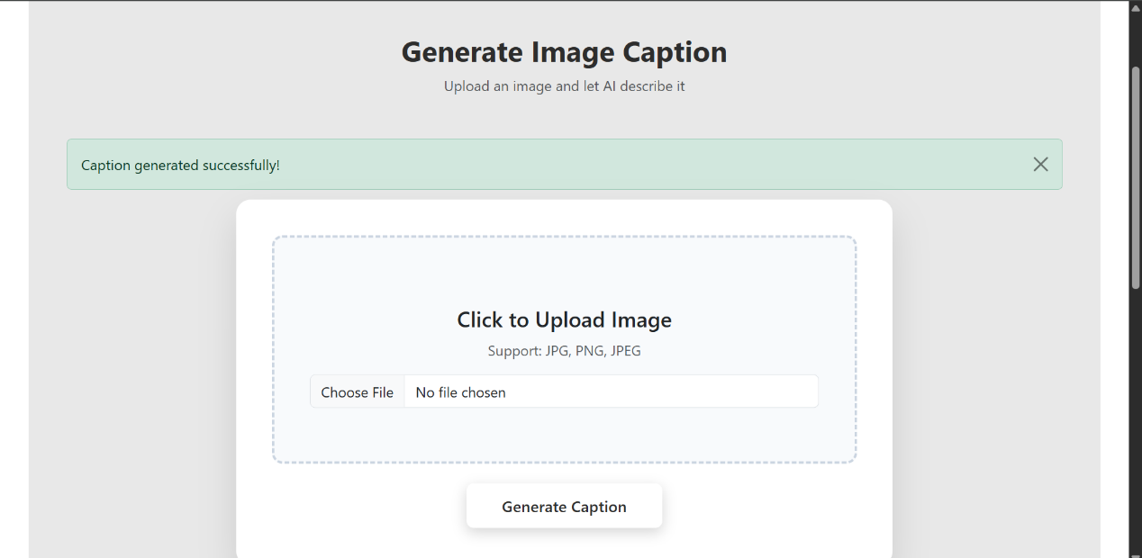
Appendix 7.2 :Home Page

